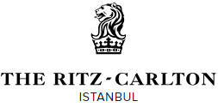

THE RITZ–CARLTON, ISTANBUL FACT SHEET
Location:
Set along the Bosphorus in the upscale Dolmabahçe district, The Ritz-Carlton, Istanbul overlooks the waterway from nearly every vantage point and offers an enticing collection of five-star amenities. The newly designed interiors will make The Ritz-Carlton, Istanbul the hotel of choice for travellers looking for the opulence, culture and tradition of Turkey with modern twist.
Accommodation:
The Ritz-Carlton, Istanbul will offer 243 newly renovated luxury guest rooms including 23 suites with views that allow guests to admire the city, from the Bosphorus to the Domes Mosque. All suites and rooms feature a neoclassic décor and Turkish-inspired style. Guests in suites can enjoy “A hotel within a hotel” with complimentary access to the Ritz-Carlton Club located on the top floors of the hotel.

The following complimentary services are available to all in-house guests:
- Twenty-four-hour in-room dining available
- Day and evening turndown service
- Pillow menu to suit your preference
- Laundry and dry-cleaning services
- Shoe shine service upon request
- Complimentary newspaper upon request
- Free access to Spa featuring indoor pool, Turkish hammam, sauna, steam room, fitness centre
- Free access to outdoor resting pool and Jacuzzis during summer
- Multi-line phones with voicemail
- In-room Nespresso coffee machine

Spa and Fitness Centre:
The Spa at the Ritz-Carlton, Istanbul takes guests on healing journey starting from within. The traditional Turkish Hammam is the spa’s impressive centrepiece, modelled after 16th century Turkish baths. The menu also features facial, massage and body treatments. In the summer, Open Air Terrace serves hotel guests and locals with its refreshing Jacuzzis, infinity pool, and spacious sunbathing lounge looking over the Bosphorus as well as a peaceful cabana providing an open-air massage experience.

The following amenities can be enjoyed by all in-house guests:
- Indoor swimming pool
- Jacuzzi
- Infinity pool
- Sauna and steam room
- Fitness centre with Techno-gym fitness machines

Restaurants and Bars:
Atelier Real Food
fresh, local farm-to-table dishes in a fine dining setting the Atelier Real Food restaurant offers culinary excellence with unparalleled Bosphorus views. For those seeking ultimate exclusivity and a showcase cellar with 150 local and international wines, guests can dine at the Chef’s Table where there is access to a showcase cellar with over 150 local and international wines

Atelier Lounge
A contemporary area for guest to meet, eat and drink, the Atelier lounge in the hotel’s lobby offers bite-sized, Mediterranean-inspired Turkish cuisine with an upscale twist.

Blue Lounge
Experience the incredible views year-round at the Blue Lounge situated on the hotels uppermost floor. Guests can sip on lab inspired cocktails rain or shine under the lounge’s retractable glass roof. As the sun sets and the dazzling city lights illuminate the Bosphorus Bridge, the Blue Lounge raises the tempo upbeat music and nightly performers.

Meeting Facilities:
The Ritz-Carlton, Istanbul offers an impressive location for business and conference events boasting more than 2,500 sqm. in over 11 meeting and event spaces including a 700 sqm. Grand Ballroom. Each room celebrates the cities culture through its traditional Turkish décor while providing the modern business traveller with the latest cutting-edge technology.

Property Features & Amenities:
- Indoor swimming pool
- 24-hour fitness centre
- Full-service spa with Turkish hammam
- Wi-Fi in all public spaces
- Barrier-free accessibility for handicapped guests
- On-site jewellery and gift shops
- Concierge services (for dining reservations, golf tee times, etc.)
- Valet parking
- Shoeshine Service
- Safe-deposit boxes
- Laundry and dry cleaning
- Hair dresser and barber shop
- ATM machine

General Manager
Nicolas A. Kipper

Management Company
Marriott International

Rates
Prices will start from €399 inc. VAT

Address
Suzer Plaza, Askerocagi Cad. No:6
3436, Elmadag, Sisli,
Istanbul, Turkey

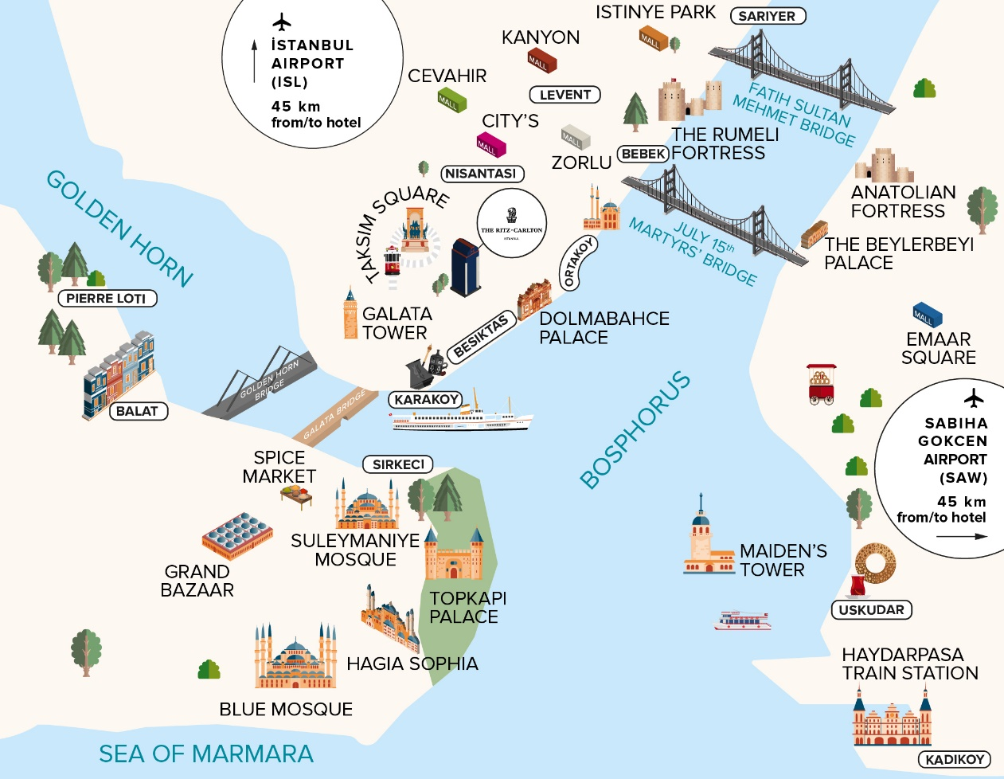

Contacts
Telephone: +90 (212) 334-444 | Email: rc.istrz.leads@ritzcarlton.com |
Web: http://www.ritzcarlton.com/en/hotels/europe/istanbul

Connect
Facebook: facebook.com/ritzcarltonistanbul/ | Instagram: @RitzCarltonIstanbul

Arrival
The hotel is a forty-five-minute drive from Istanbul Airport (40 km/25 miles) and a ninety-minute drive from Sabiha Gökçen International Airport (50 km/ 31 miles). In addition, the Galataport, a terminal for luxury cruise ships, is less than three kilometres from the hotel.

Parking Fees
40.00 TL per night, valet parking only

For further press information or images please contact:
Elif Bilge Aytekin, PR & Marketing Manager
T: +90 212 334 44 44 | elif.aytekin@ritzcarlton.com

